**MySQL to MongoDB Migration Hands-on**

**Business Case**: Moving the database from a relational database to a non-relational one.

**Process**: Migrate the existing database to a non-relational database. Verify connectivity and data retrieval.

**Main Tasks**

1. Backup MySQL Data.
2. Create Database and collections in MongoDB.
3. Get the DB user credentials for MongoDB.
4. Upload the table data into Mongodb collection.
5. Compare and Test.
6. **Backup MySQL Data**
7. Open MySQL Workbench.
8. Connect to the database.
9. Select all data from tbl_college
10. Save the data to csv file.



1. Repeat the same for other tables.
2. **Create Database and collections in Mongodb collection.**
3. Log in to the Atlas account <https://account.mongodb.com/account/login>
4. Open the Cluster, Click Browse Collections, Add My Own Data

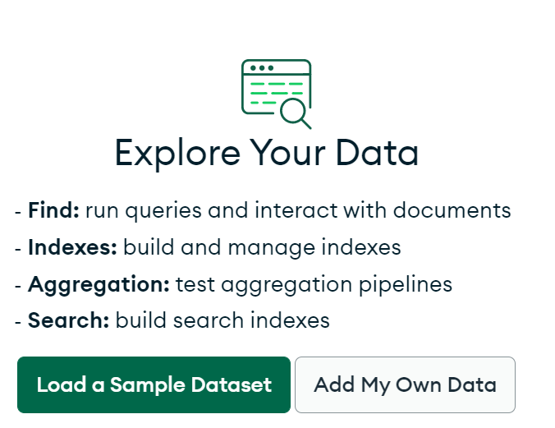

1. Click create database. Enter database name as college_mgmt and collection as college.

1. Click + symbol near college_mgmt. Enter student to create student collection.

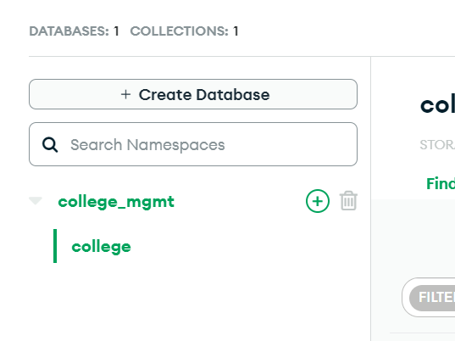

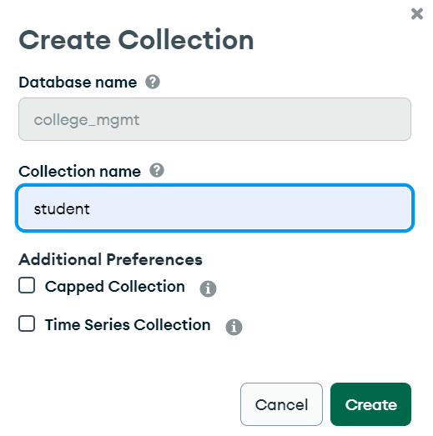

1. Similarly, create users and roles collections.
2. **Get the DB user credentials for MongoDB.**
3. Copy the below command in a notepad and update the parameters in the below steps.

mongoimport --uri mongodb+srv://<Username>:<password>@<clustername>/college_mgmt --collection college --type CSV --headerline --file <csv file name>

1. Click on Connect button.

1. Click on Connect your application and get hostname.

1. Get DB Access details.

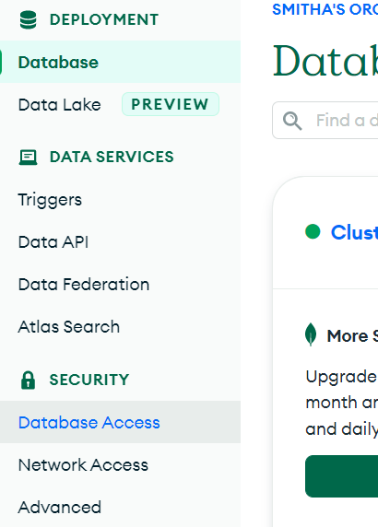

1. Check the Network Access

1. **Migrate the data using Mongo import.**
2. Open cmd in your laptop, go to folder where csv is stored.
3. Enter the command after updating username, password, hostname and filename.

mongoimport --uri mongodb+srv://<Username>:<password>@<clustername>/college_mgmt --collection college --type CSV --headerline --file <csv file name>

1. Repeat the same for other tables.



1. **Compare data**
2. Verify the collection data (Format ex. { collegename : “Test College 1” } )

1. Compare with MySQL.